# Java

I Use Java Development Tool Kit version 8 (jdk-8u5-windows-x64).

# Android

I Use proper version of android according my mobile android version.

|  |  |  |  |
| --- | --- | --- | --- |
| Platform Version | API Level | VERSION_CODE | Notes |
| [Android 4.4](http://developer.android.com/about/versions/android-4.4.html) | [19](http://developer.android.com/sdk/api_diff/19/changes.html) | [KITKAT](http://developer.android.com/reference/android/os/Build.VERSION_CODES.html#KITKAT) | [Platform Highlights](http://developer.android.com/about/versions/kitkat.html) |
| [Android 4.3](http://developer.android.com/about/versions/android-4.3.html) | [18](http://developer.android.com/sdk/api_diff/18/changes.html) | [JELLY_BEAN_MR2](http://developer.android.com/reference/android/os/Build.VERSION_CODES.html#JELLY_BEAN_MR2) | [Platform Highlights](http://developer.android.com/about/versions/jelly-bean.html) |
| [Android 4.2, 4.2.2](http://developer.android.com/about/versions/android-4.2.html) | [17](http://developer.android.com/sdk/api_diff/17/changes.html) | [JELLY_BEAN_MR1](http://developer.android.com/reference/android/os/Build.VERSION_CODES.html#JELLY_BEAN_MR1) | [Platform Highlights](http://developer.android.com/about/versions/jelly-bean.html#android-42) |
| [Android 4.1, 4.1.1](http://developer.android.com/about/versions/android-4.1.html) | [16](http://developer.android.com/sdk/api_diff/16/changes.html) | [JELLY_BEAN](http://developer.android.com/reference/android/os/Build.VERSION_CODES.html#JELLY_BEAN) | [Platform Highlights](http://developer.android.com/about/versions/jelly-bean.html#android-41) |
| [Android 4.0.3, 4.0.4](http://developer.android.com/about/versions/android-4.0.3.html) | [15](http://developer.android.com/sdk/api_diff/15/changes.html) | [ICE_CREAM_SANDWICH_MR1](http://developer.android.com/reference/android/os/Build.VERSION_CODES.html#ICE_CREAM_SANDWICH_MR1) | [Platform Highlights](http://developer.android.com/about/versions/android-4.0-highlights.html) |
| [Android 4.0, 4.0.1, 4.0.2](http://developer.android.com/about/versions/android-4.0.html) | [14](http://developer.android.com/sdk/api_diff/14/changes.html) | [ICE_CREAM_SANDWICH](http://developer.android.com/reference/android/os/Build.VERSION_CODES.html#ICE_CREAM_SANDWICH) |
| [Android 3.2](http://developer.android.com/about/versions/android-3.2.html) | [13](http://developer.android.com/sdk/api_diff/13/changes.html) | [HONEYCOMB_MR2](http://developer.android.com/reference/android/os/Build.VERSION_CODES.html#HONEYCOMB_MR2) |  |
| [Android 3.1.x](http://developer.android.com/about/versions/android-3.1.html) | [12](http://developer.android.com/sdk/api_diff/12/changes.html) | [HONEYCOMB_MR1](http://developer.android.com/reference/android/os/Build.VERSION_CODES.html#HONEYCOMB_MR1) | [Platform Highlights](http://developer.android.com/about/versions/android-3.1-highlights.html) |
| [Android 3.0.x](http://developer.android.com/about/versions/android-3.0.html) | [11](http://developer.android.com/sdk/api_diff/11/changes.html) | [HONEYCOMB](http://developer.android.com/reference/android/os/Build.VERSION_CODES.html#HONEYCOMB) | [Platform Highlights](http://developer.android.com/about/versions/android-3.0-highlights.html) |
| [Android 2.3.4 Android 2.3.3](http://developer.android.com/about/versions/android-2.3.3.html) | [10](http://developer.android.com/sdk/api_diff/10/changes.html) | [GINGERBREAD_MR1](http://developer.android.com/reference/android/os/Build.VERSION_CODES.html#GINGERBREAD_MR1) | [Platform Highlights](http://developer.android.com/about/versions/android-2.3-highlights.html) |
| [Android 2.3.2 Android 2.3.1 Android 2.3](http://developer.android.com/about/versions/android-2.3.html) | [9](http://developer.android.com/sdk/api_diff/9/changes.html) | [GINGERBREAD](http://developer.android.com/reference/android/os/Build.VERSION_CODES.html#GINGERBREAD) |
| [Android 2.2.x](http://developer.android.com/about/versions/android-2.2.html) | [8](http://developer.android.com/sdk/api_diff/8/changes.html) | [FROYO](http://developer.android.com/reference/android/os/Build.VERSION_CODES.html#FROYO) | [Platform Highlights](http://developer.android.com/about/versions/android-2.2-highlights.html) |
| [Android 2.1.x](http://developer.android.com/about/versions/android-2.1.html) | [7](http://developer.android.com/sdk/api_diff/7/changes.html) | [ECLAIR_MR1](http://developer.android.com/reference/android/os/Build.VERSION_CODES.html#ECLAIR_MR1) | [Platform Highlights](http://developer.android.com/about/versions/android-2.0-highlights.html) |
| [Android 2.0.1](http://developer.android.com/about/versions/android-2.0.1.html) | [6](http://developer.android.com/sdk/api_diff/6/changes.html) | [ECLAIR_0_1](http://developer.android.com/reference/android/os/Build.VERSION_CODES.html#ECLAIR_0_1) |
| [Android 2.0](http://developer.android.com/about/versions/android-2.0.html) | [5](http://developer.android.com/sdk/api_diff/5/changes.html) | [ECLAIR](http://developer.android.com/reference/android/os/Build.VERSION_CODES.html#ECLAIR) |
| [Android 1.6](http://developer.android.com/about/versions/android-1.6.html) | [4](http://developer.android.com/sdk/api_diff/4/changes.html) | [DONUT](http://developer.android.com/reference/android/os/Build.VERSION_CODES.html#DONUT) | [Platform Highlights](http://developer.android.com/about/versions/android-1.6-highlights.html) |
| [Android 1.5](http://developer.android.com/about/versions/android-1.5.html) | [3](http://developer.android.com/sdk/api_diff/3/changes.html) | [CUPCAKE](http://developer.android.com/reference/android/os/Build.VERSION_CODES.html#CUPCAKE) | [Platform Highlights](http://developer.android.com/about/versions/android-1.5-highlights.html) |
| [Android 1.1](http://developer.android.com/about/versions/android-1.1.html) | 2 | [BASE_1_1](http://developer.android.com/reference/android/os/Build.VERSION_CODES.html#BASE_1_1) |  |
| Android 1.0 | 1 | [BASE](http://developer.android.com/reference/android/os/Build.VERSION_CODES.html#BASE) |  |

# GeNIe

I Install GeNIe 2.0.

GeNIe's name and its uncommon capitalization originates from the name Graphical Network Interface, given to the original simple interface to SMILE, our library of functions for graphical probabilistic and decision-theoretic models. GeNIe is an outer shell to SMILE.

SMILE (Structural Modeling, Inference, and Learning Engine) is a fully platform independent library of functions implementing graphical probabilistic and decision-theoretic models, such as [Bayesian networks](mk:@MSITStore:C:\Program%20Files%20(x86)\GeNIe%202.0\genie.CHM::/Decision-theoretic_Modeling/BBNs.htm), [influence diagrams](mk:@MSITStore:C:\Program%20Files%20(x86)\GeNIe%202.0\genie.CHM::/Decision-theoretic_Modeling/IDs.htm), and structural equation models.

# Android Virtual Device (AVD)

|  |  |  |  |  |  |  |  |  |  |  |  |  |  |  |  |  |  |  |  |  |  |  |  |  |  |  |  |  |  |  |  |  |  |  |  |  |  |  |  |  |  |  |  |  |  |  |  |  |  |  |  |  |  |  |  |  |  |  |  |  |  |  |  |  |  |  |  |  |  |  |  |  |  |  |  |  |  |  |  |  |  |  |  |  |  |  |  |  |  |  |  |  |  |
| --- | --- | --- | --- | --- | --- | --- | --- | --- | --- | --- | --- | --- | --- | --- | --- | --- | --- | --- | --- | --- | --- | --- | --- | --- | --- | --- | --- | --- | --- | --- | --- | --- | --- | --- | --- | --- | --- | --- | --- | --- | --- | --- | --- | --- | --- | --- | --- | --- | --- | --- | --- | --- | --- | --- | --- | --- | --- | --- | --- | --- | --- | --- | --- | --- | --- | --- | --- | --- | --- | --- | --- | --- | --- | --- | --- | --- | --- | --- | --- | --- | --- | --- | --- | --- | --- | --- | --- | --- | --- | --- | --- | --- | --- |
| |  |  |  |  |  |  |  |  |  |  |  |  |  |  |  |  |  |  |  |  |  |  |  |  |  |  |  |  |  |  |  |  |  |  |  |  |  |  |  |  |  |  |  |  |  |  |  |  |  |  |  |  |  |  |  |  |  |  |  |  |  |  |  |  |  |  |  |  |  |  |  |  |  |  |  |  |  |  |  |  |  |  |  |  |  |  |  |  |  |  |  |  |  | | --- | --- | --- | --- | --- | --- | --- | --- | --- | --- | --- | --- | --- | --- | --- | --- | --- | --- | --- | --- | --- | --- | --- | --- | --- | --- | --- | --- | --- | --- | --- | --- | --- | --- | --- | --- | --- | --- | --- | --- | --- | --- | --- | --- | --- | --- | --- | --- | --- | --- | --- | --- | --- | --- | --- | --- | --- | --- | --- | --- | --- | --- | --- | --- | --- | --- | --- | --- | --- | --- | --- | --- | --- | --- | --- | --- | --- | --- | --- | --- | --- | --- | --- | --- | --- | --- | --- | --- | --- | --- | --- | --- | --- | | Samsung Galaxy Pocket plus S5301  [Samsung](http://www.gsmarena.com/samsung-phones-9.php)  [Samsung Galaxy Pocket plus S5301 MORE PICTURES](http://www.gsmarena.com/samsung_galaxy_pocket_plus_s5301-pictures-5461.php)  Bottom of Form   |  |  |  | | --- | --- | --- | | **General** | [2G Network](http://www.gsmarena.com/network-bands.php3) | GSM 850 / 900 / 1800 / 1900 | | [3G Network](http://www.gsmarena.com/network-bands.php3) | HSDPA 900 / 2100 | | [SIM](http://www.gsmarena.com/glossary.php3?term=sim) | Mini-SIM | | [Announced](http://www.gsmarena.com/samsung_galaxy_pocket_plus_s5301-5461.php) | 2012 | | [Status](http://www.gsmarena.com/samsung_galaxy_pocket_plus_s5301-5461.php) | Available. Released 2012 |  |  |  |  | | --- | --- | --- | | **Body** | [Dimensions](http://www.gsmarena.com/samsung_galaxy_pocket_plus_s5301-5461.php) | 104.9 x 57.9 x 12 mm (4.13 x 2.28 x 0.47 in) | | [Weight](http://www.gsmarena.com/samsung_galaxy_pocket_plus_s5301-5461.php) | 97.2 g (3.42 oz) |  |  |  |  | | --- | --- | --- | | **Display** | [Type](http://www.gsmarena.com/glossary.php3?term=display-type) | TFT capacitive touchscreen, 256K colors | | [Size](http://www.gsmarena.com/samsung_galaxy_pocket_plus_s5301-5461.php) | 240 x 320 pixels, 2.8 inches (~143 ppi pixel density) | | [Multitouch](http://www.gsmarena.com/glossary.php3?term=multitouch) | Yes | |  | - TouchWiz UX UI |  |  |  |  | | --- | --- | --- | | **Sound** | [Alert types](http://www.gsmarena.com/glossary.php3?term=call-alerts) | Vibration, MP3 ringtones | | [Loudspeaker](http://www.gsmarena.com/glossary.php3?term=loudspeaker) | Yes | | [3.5mm jack](http://www.gsmarena.com/glossary.php3?term=audio-jack) | Yes |  |  |  |  | | --- | --- | --- | | **Memory** | [Card slot](http://www.gsmarena.com/glossary.php3?term=memory-card-slot) | microSD, up to 32 GB | | [Internal](http://www.gsmarena.com/glossary.php3?term=dynamic-memory) | 4 GB, 512 MB RAM |  |  |  |  | | --- | --- | --- | | **Data** | [GPRS](http://www.gsmarena.com/glossary.php3?term=gprs) | Class 12 (4+1/3+2/2+3/1+4 slots), 32 - 48 kbps | | [EDGE](http://www.gsmarena.com/glossary.php3?term=edge) | Class 12 | | [Speed](http://www.gsmarena.com/glossary.php3?term=3g) | HSDPA, 7.2 Mbps; HSUPA, 5.76 Mbps | | [WLAN](http://www.gsmarena.com/glossary.php3?term=wi-fi) | Wi-Fi 802.11 b/g/n, Wi-Fi Direct, Wi-Fi hotspot | | [Bluetooth](http://www.gsmarena.com/glossary.php3?term=bluetooth) | Yes, v4.0 with A2DP | | [USB](http://www.gsmarena.com/glossary.php3?term=usb) | Yes, microUSB v2.0 |  |  |  |  | | --- | --- | --- | | **Camera** | [Primary](http://www.gsmarena.com/glossary.php3?term=camera) | 2 MP, 1600 x 1200 pixels | | [Features](http://www.gsmarena.com/glossary.php3?term=camera) | Geo-tagging, smile detection, panorama | | [Video](http://www.gsmarena.com/glossary.php3?term=camera) | Yes, QVGA@30fps | | [Secondary](http://www.gsmarena.com/glossary.php3?term=video-call) | No |  |  |  |  | | --- | --- | --- | | **Features** | [OS](http://www.gsmarena.com/glossary.php3?term=os) | Android OS, v4.0 (Ice Cream Sandwich) | | [CPU](http://www.gsmarena.com/glossary.php3?term=cpu) | 850 MHz | | [Sensors](http://www.gsmarena.com/glossary.php3?term=sensors) | Accelerometer | | [Messaging](http://www.gsmarena.com/glossary.php3?term=messaging) | SMS(threaded view), MMS, Email, Push Mail, IM, RSS | | [Browser](http://www.gsmarena.com/glossary.php3?term=browser) | HTML | | [Radio](http://www.gsmarena.com/glossary.php3?term=fm-radio) | Stereo FM radio with RDS | | [GPS](http://www.gsmarena.com/glossary.php3?term=gps) | Yes, with A-GPS support and GLONASS | | [Java](http://www.gsmarena.com/glossary.php3?term=java) | Yes, via Java MIDP emulator | | [Colors](http://www.gsmarena.com/samsung_galaxy_pocket_plus_s5301-5461.php) | Black, White | |  | - SNS integration - MP4/H.264/H.263 player - MP3/WAV/eAAC+ player - Organizer - Image/video editor - Document viewer - Google Search, Maps, Gmail, YouTube, Calendar, Google Talk, Picasa - Voice memo/dial - Predictive text input |  |  |  |  | | --- | --- | --- | | **Battery** |  | Li-Ion 1200 mAh battery | | [Stand-by](http://www.gsmarena.com/glossary.php3?term=stand-by-time) | Up to 520 h (2G) / Up to 320 h (3G) | | [Talk time](http://www.gsmarena.com/glossary.php3?term=talk-time) | Up to 14 h 10 min (2G) / Up to 5 h 40 min (3G) |  |  |  |  | | --- | --- | --- | | **Misc** | [SAR US](http://www.gsmarena.com/glossary.php3?term=sar) | 1.12 W/kg (head)     0.82 W/kg (body) | | [SAR EU](http://www.gsmarena.com/glossary.php3?term=sar) | 0.70 W/kg (head)     0.28 W/kg (body) | | |

# Main Codes

**public** **class** SensorDetailFragment **extends** Fragment **implements**

SensorEventListener, LocationListener {

...

**private** **void** setup() {

....

LocationManager locationManager = (LocationManager) getActivity()

.getSystemService(Context.*LOCATION_SERVICE*);

locationManager.requestLocationUpdates(

LocationManager.*GPS_PROVIDER*, 0, 0, **this**);

SensorManager sensorManager = (SensorManager) getActivity()

.getSystemService(Context.*SENSOR_SERVICE*);

List<Sensor> sensors = sensorManager.getSensorList(Sensor.*TYPE_ALL*);

**for** (Sensor sensor : sensors) {

sensorManager.registerListener(**this**, sensor, SensorManager.*SENSOR_DELAY_NORMAL*);

String type = "";

**if** (Sensor.*TYPE_ACCELEROMETER* == sensor.getType())

type = "Accelerometer";

...

@Override

**public** **void** onLocationChanged(Location location) {

**double** x = location.getLatitude();

**double** y = location.getLongitude();

**double** z = location.getAltitude();

**double** v = location.getSpeed();

...

**public** **void** onSensorChanged(SensorEvent event) {

String name = event.sensor.getName();

**float**[] values = event.values;

# Fantastic Project

Running the project:

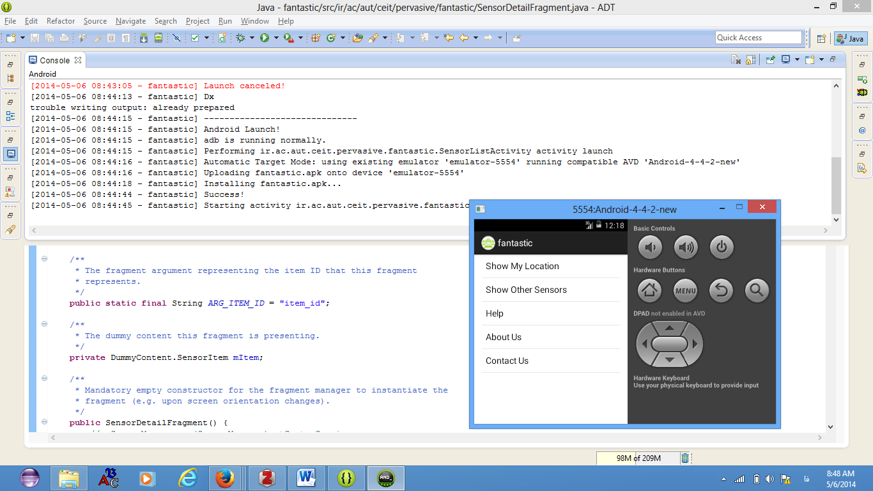

Home Page:



Show My Location: (values is not show in simulator)

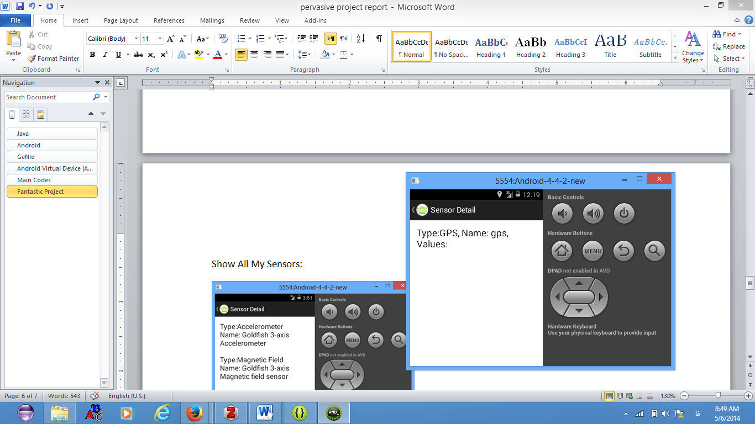

Show All My Sensors: (values is not show in simulator)

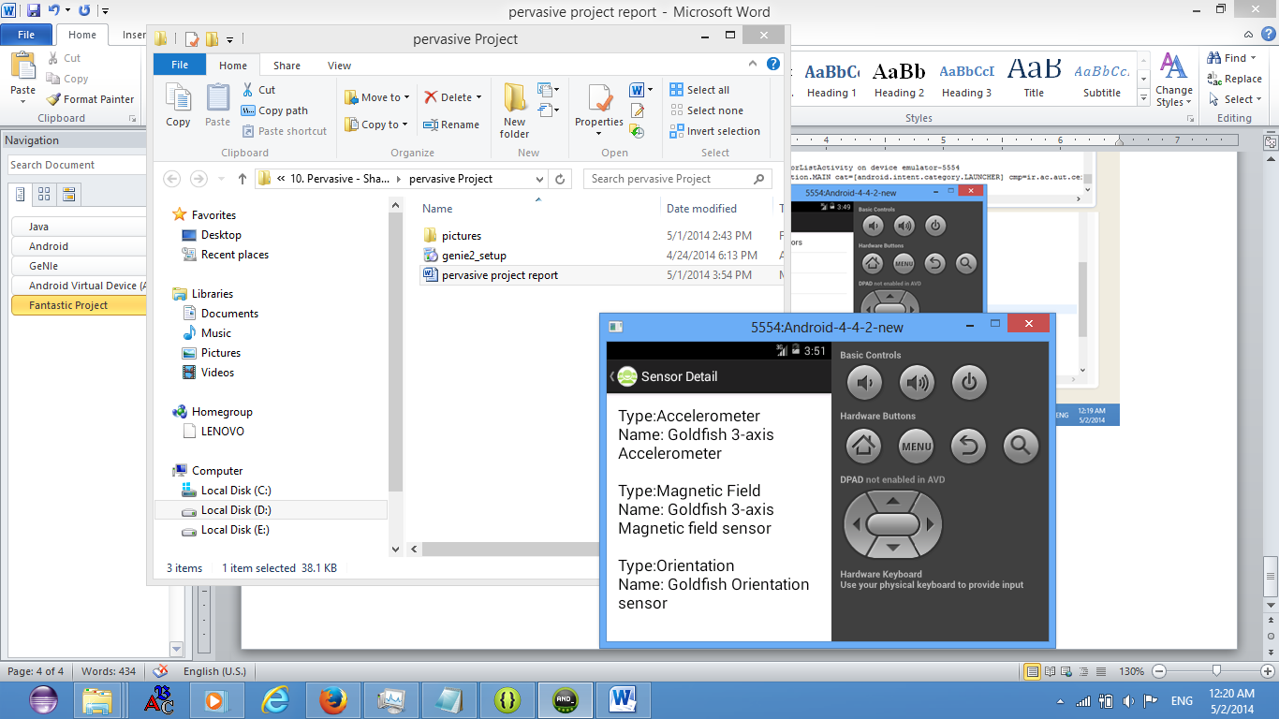

Help:

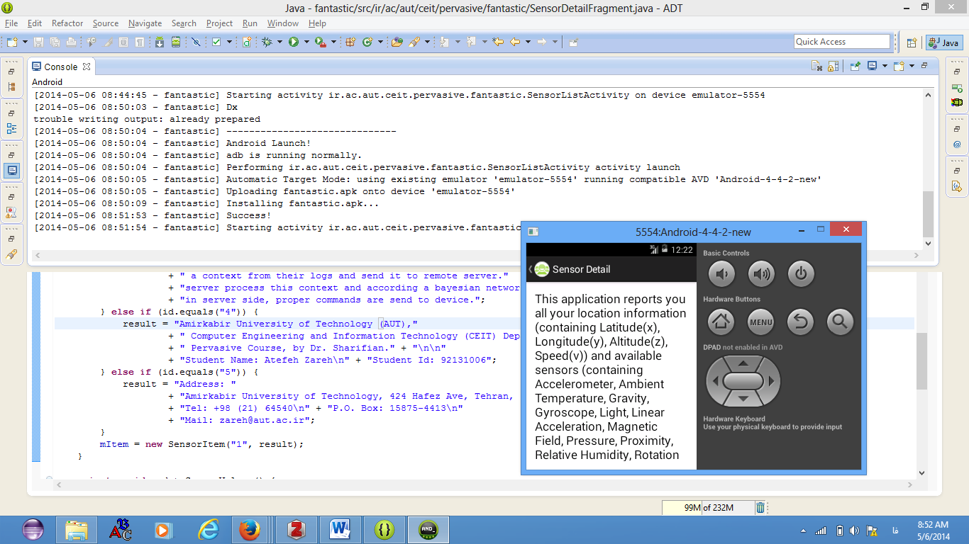

About Us:

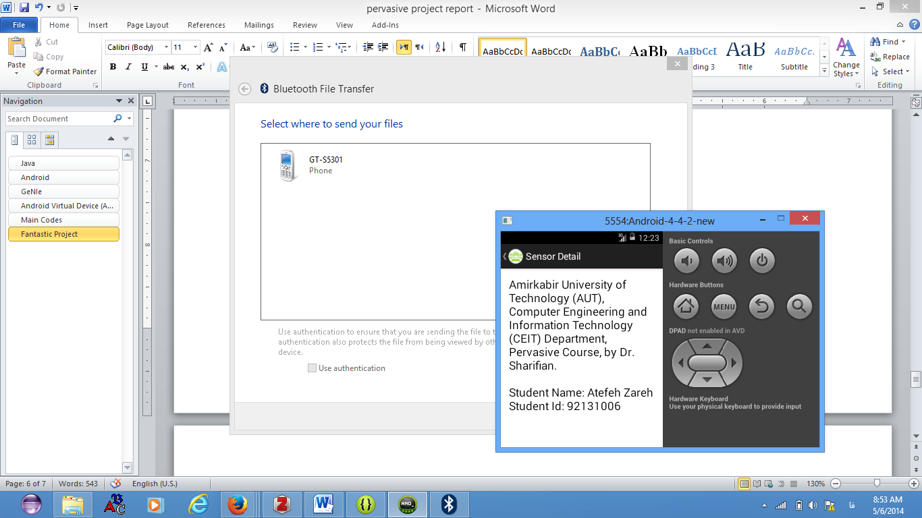

Contact Us:

